Code:

GITHUB REPO LINK

https://github.com/tahir112-britan/BeeGeez/blob/main/beegeez_sales_data_sqlite3.db



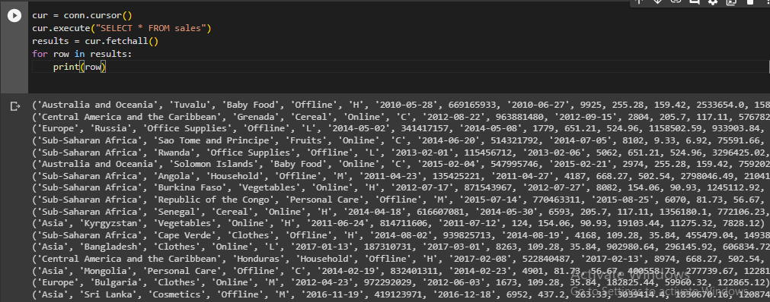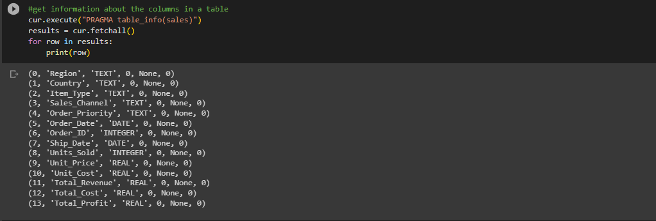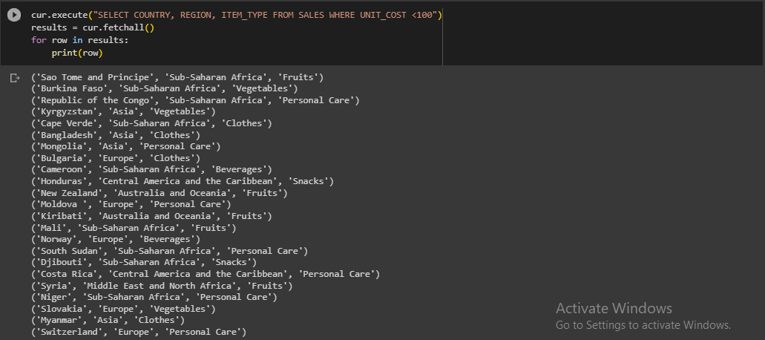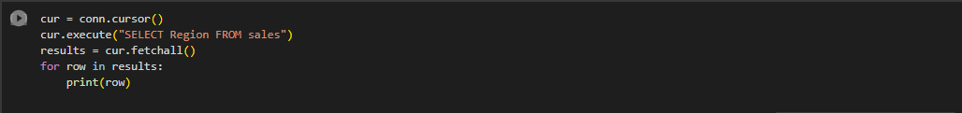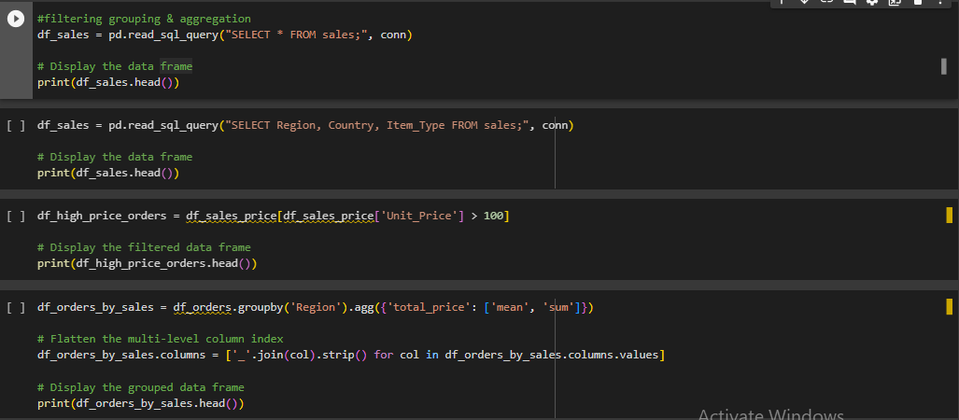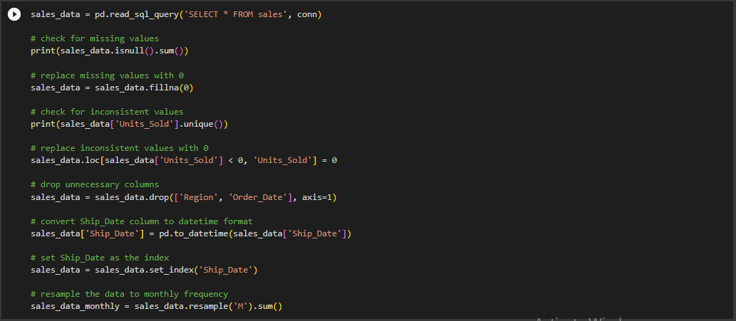

**Interpretation and conclusion:**

**Summaries the potential insights outlined in my previous response,**

The potential insights outlined in my previous response, some possible insights that could be gained from analyzing the sales data in the BeeGeez dataset include:

Identification of top-selling products or product categories

* Trends and patterns in sales over time
* Insights into customer behavior and preferences
* Evaluation of sales channel effectiveness
* Opportunities for pricing optimization

These insights could be used to inform marketing and sales strategies, product development efforts, and pricing decisions, among other things. However, it is important to note that the specific insights gained will depend on the data available and the analysis methods used.

**Discuss any limitations of your analysis and suggest possible improvements**

Data analysis may have limitations that could affect the accuracy or completeness of the insights gained. Here are some possible limitations to consider and suggestions for improvements:

Data Quality: The accuracy and completeness of the data may be limited by errors or inconsistencies in data collection, recording, or processing. To improve data quality, it's essential to validate the data at each stage, apply data cleaning techniques, and verify data accuracy before starting the analysis.

Data Availability: The analysis may be limited by the availability of data. To obtain a complete picture of a phenomenon, it may be necessary to collect additional data, including external datasets, customer surveys, or other sources of information.

Analysis Techniques: The choice of analysis techniques may affect the accuracy and completeness of the insights gained. It is essential to choose appropriate statistical and machine learning methods that are suited to the data and the research question.

Generalizability: The insights gained from the analysis may not be generalizable to other contexts or populations. To improve generalizability, it's important to carefully document the data and analysis methods and to validate the results against external benchmarks.

Interpretation: The interpretation of the analysis results may be subjective and influenced by personal biases or assumptions. To improve interpretation, it's essential to clearly articulate the research questions and hypotheses, validate the results using alternative methods, and to invite feedback from other researchers or stakeholders.

To overcome these limitations and improve the accuracy and completeness of data analysis, it is essential to apply best practices in data management, analysis, and interpretation. This includes carefully selecting appropriate data sources, conducting rigorous data cleaning and validation procedures, using appropriate analysis techniques, and being transparent and reflective in interpreting the results. Additionally, it may be helpful to collaborate with domain experts or other stakeholders to ensure the analysis is relevant and actionable.

**Reflect on the usability and effectiveness of Python notebooks**

Python notebooks, such as Jupyter Notebook and Google Colab, are popular tools for data analysis and scientific computing. They provide an interactive environment for data exploration, modeling, and visualization, allowing users to combine code, text, and multimedia elements in a single document.

One of the main advantages of Python notebooks is their ease of use and flexibility. They allow users to quickly prototype and test code, visualize data, and share results with others. They also support a wide range of programming languages, data formats, and libraries, making them a powerful tool for data analysis and machine learning.

Python notebooks are also effective for collaboration, as they allow multiple users to work on the same document simultaneously, making it easy to share code, results, and insights with others. Additionally, notebooks can be version-controlled using tools like Git, making it easy to track changes over time and collaborate with others.

However, Python notebooks also have some limitations that can affect their usability and effectiveness. For example, they can be memory-intensive, making it difficult to work with large datasets or complex models. They can also be prone to errors and inconsistencies, especially when working with multiple programming languages or libraries.

To overcome these limitations, it is important to carefully manage the notebook environment, including selecting appropriate hardware and software configurations, optimizing code and data structures, and documenting the analysis workflow. It is also important to be aware of the limitations of the tools being used and to seek out additional resources and support when needed.

Overall, Python notebooks are a valuable tool for data analysis and scientific computing, providing an easy-to-use, flexible, and collaborative environment for exploring data, building models, and sharing insights. With careful attention to best practices and limitations, they can be an effective tool for researchers and data scientists in a variety of fields.

**GROUP A**

**Q1**

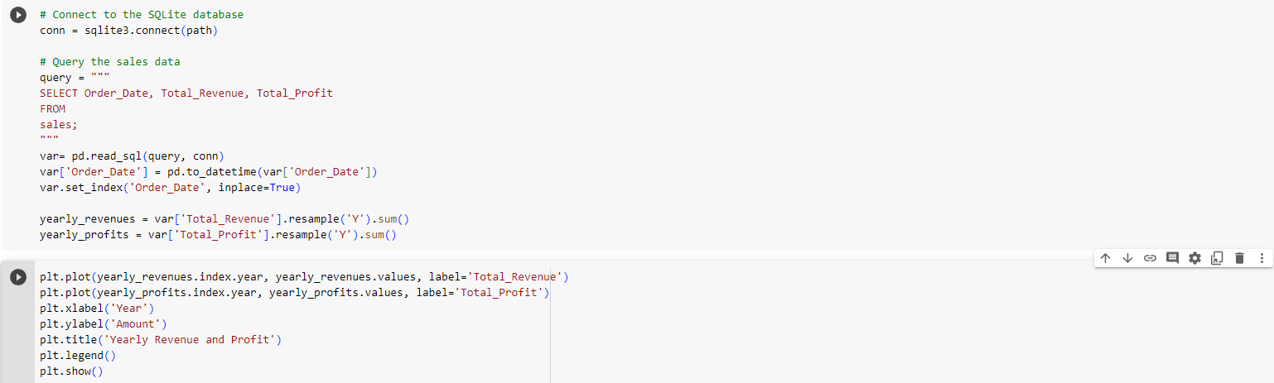

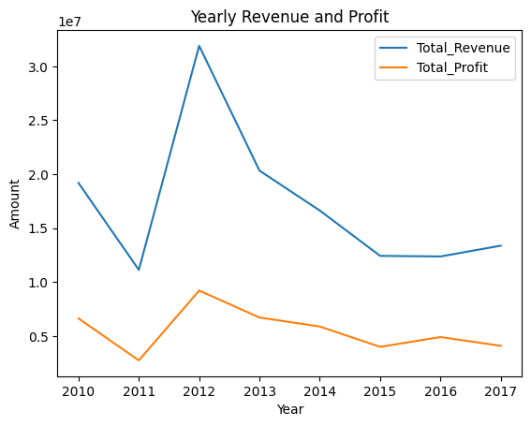

**Q2**

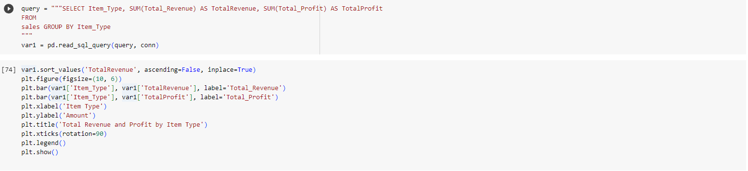

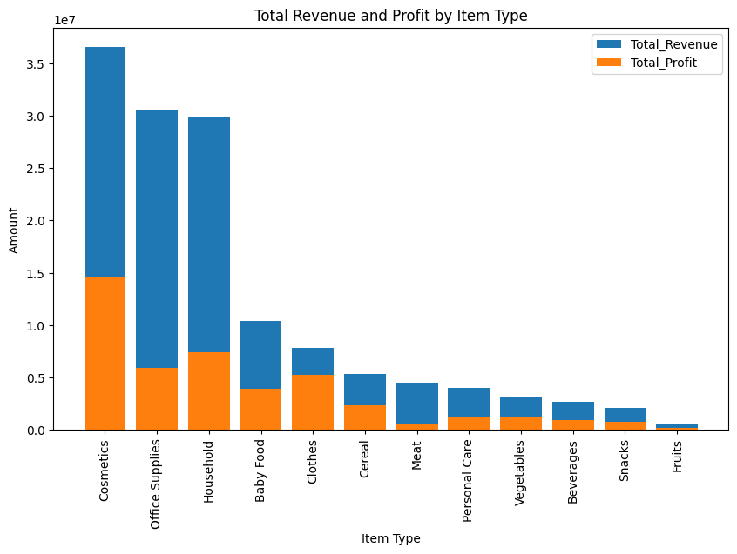**.**

**Q3**

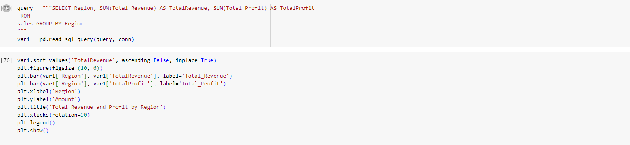

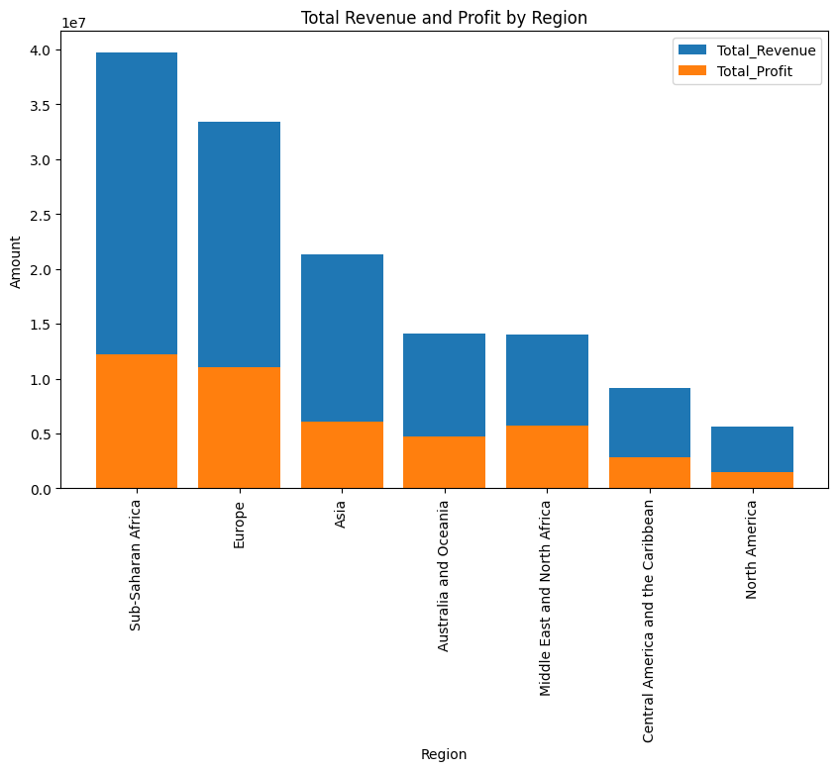

**GROUP B**

**Q1**

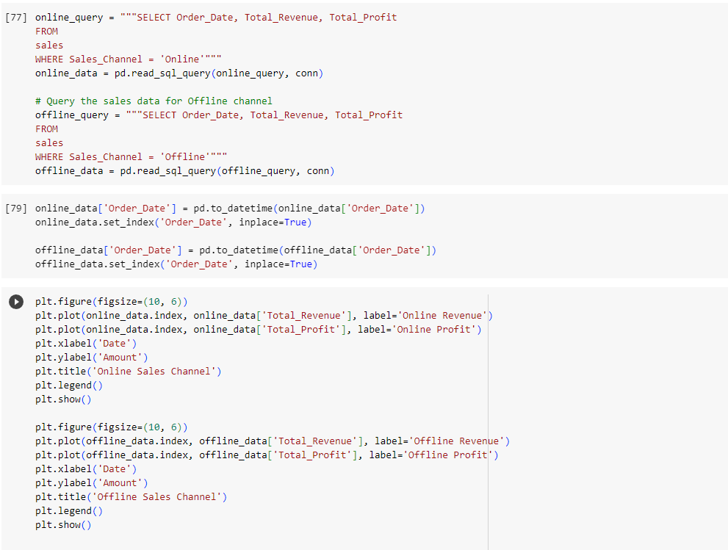

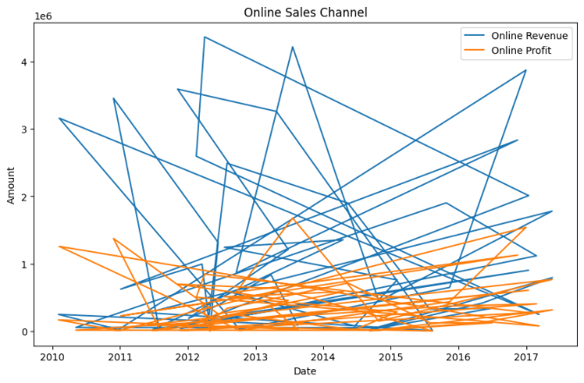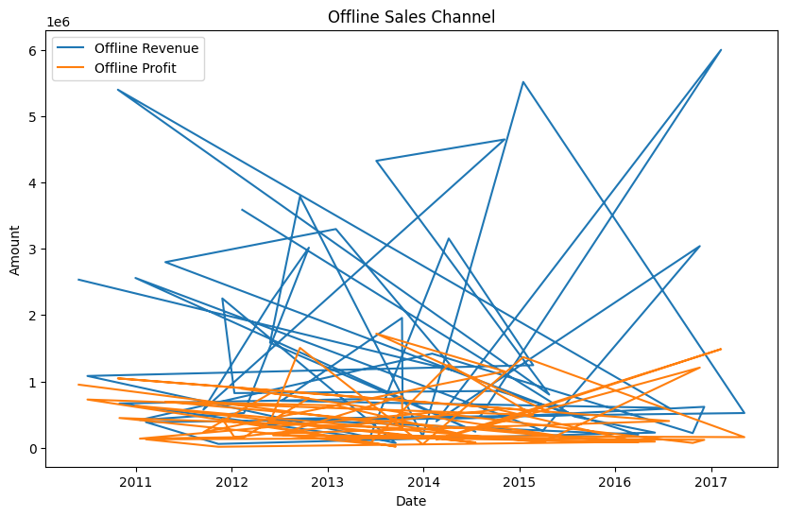

**Q2**

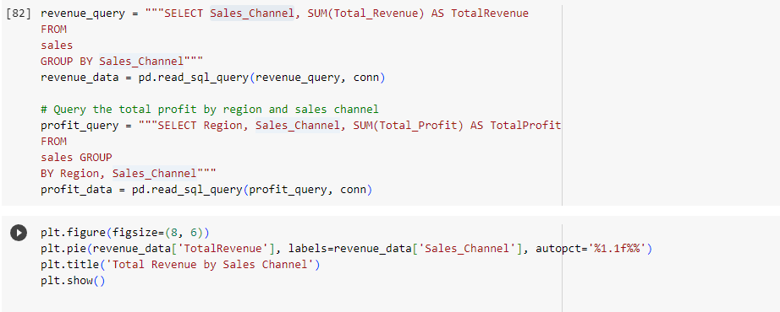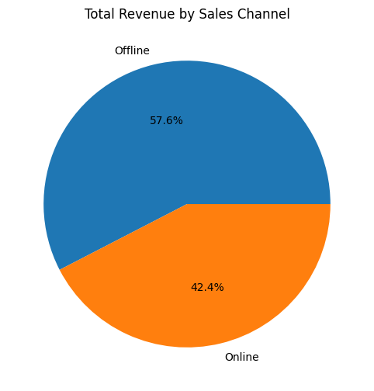

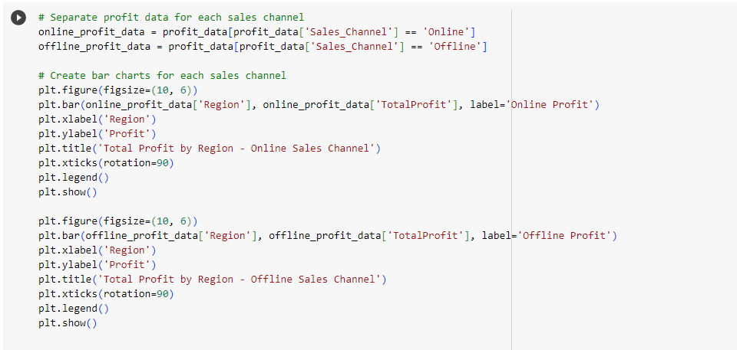

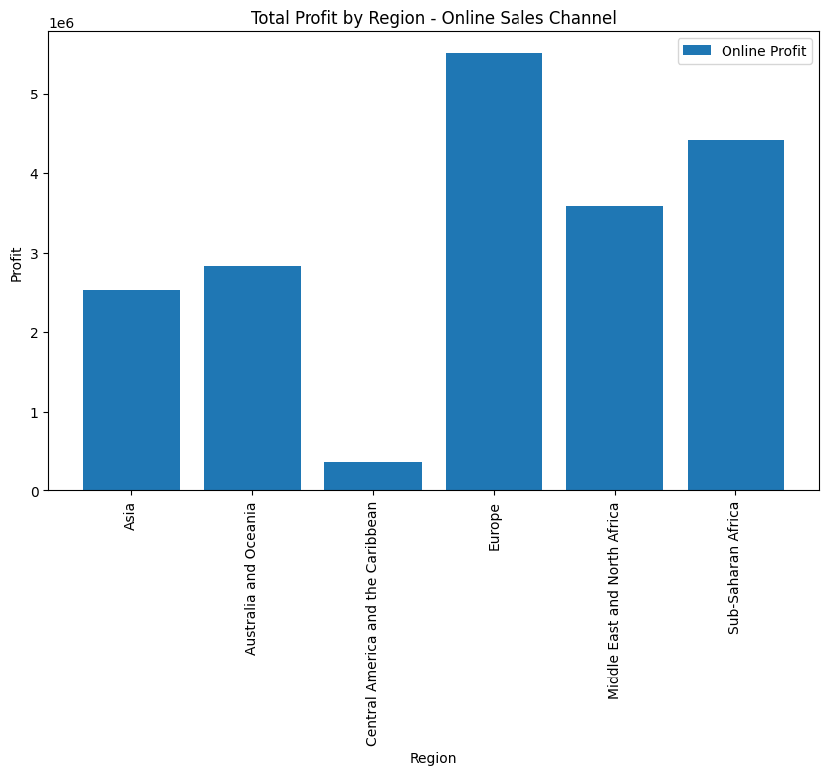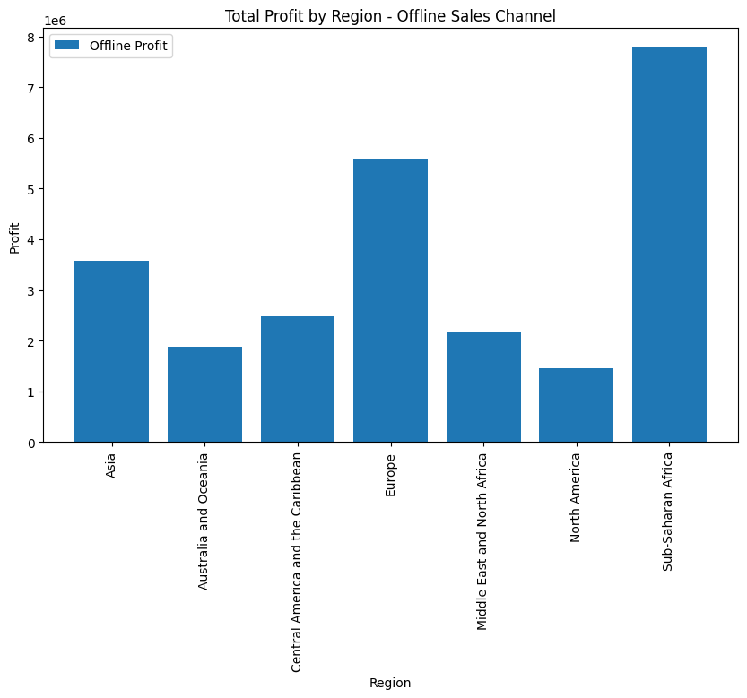

**Q3**

